**Turkey Profile - Timeline**

5 January 2017

From the section [Europe](http://www.bbc.com/news/world/europe)

Top of Form

Bottom of Form

**A chronology of key events:**

**Ottoman Empire**

**1453**- Sultan Mehmed II the Magnificent captures Constantinople, ending Byzantine Empire and consolidating Ottoman Empire in Asia Minor and Balkans.

**15th-16th centuries** - Expansion into Asia and Africa.

**1683**- Ottoman advance into Europe halted at Battle of Vienna. Long decline begins.

**19th century**- Efforts at political and economic modernization of Empire largely founder.

**1908**- Young Turk Revolution establishes constitutional rule, but degenerates into military dictatorship during First World War, where Ottoman Empire fights in alliance with Germany and Austria-Hungary.

**1918-22**- Partition of defeated Ottoman Empire leads to eventual triumph of Turkish National Movement in war of independence against foreign occupation and rule of Sultan.

**Modern Turkey**

**1923**- Grand National Assembly declares Turkey a republic and Kemal Ataturk president.

**Istanbul**

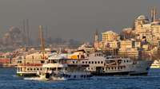

Image copyright GETTY IMAGES

Europe meets Asia in Turkey's largest city

* Former capital of Byzantine and Ottoman empires
* 1930: Constantinople officially renamed Istanbul
* Population: 9.4 million

**1928**- Turkey becomes secular: clause retaining Islam as state religion removed from constitution.

**1938**- President Ataturk dies, succeeded by Ismet Inonu.

**1945**- Neutral for most of World War II, Turkey declares war on Germany and Japan, but does not take part in combat. Joins United Nations.

**1950**- First free elections won by opposition Democratic Party.

**Military coups**

**1952**- Turkey abandons Ataturk's neutralist policy and joins NATO.

**1960**- Army coup against ruling Democratic Party.

**1963**- Association agreement signed with European Economic Community (EEC).

**Ottoman Empire**

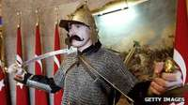

Image copyright GETTY IMAGES

Multi-ethnic state lasted more than 600 years

* Developed in late 13th century
* Extended into south-east Europe, north Africa, Middle East
* Replaced by Turkish Republic in 1922

[**Empire of the Ottomans**](http://news.bbc.co.uk/1/hi/world/europe/1749539.stm)

[**BBC: Ottoman Empire (1301-1922)**](http://www.bbc.co.uk/religion/religions/islam/history/ottomanempire_1.shtml)

**1965**- Suleyman Demirel becomes prime minister - a position he is to hold seven times.

**1971**- Army forces Demirel's resignation after spiral of political violence.

**1974**- Turkish troops invade northern Cyprus.

**1978**- US trade embargo resulting from invasion lifted.

**1980**- Military coup follows political deadlock and civil unrest. Imposition of martial law.

**1982**- New constitution creates seven-year presidency, and reduces parliament to single chamber.

**1983**- General election won by Turgut Ozal's Motherland Party.

**Kurdish war**

**1984**- Turkey recognizes "Turkish Republic of Northern Cyprus."

Kurdistan Workers' Party launches separatist guerrilla war in southeast.

**Kemal Ataturk**

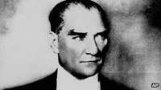

Image copyright AP

Founder of the Turkish republic

* Born in 1881
* President from 1923
* Died in 1938

[**BBC History**](http://www.bbc.co.uk/history/historic_figures/ataturk_kemal.shtml)

**1987**- Turkey applies for full EEC membership.

**1990**- Turkey allows US-led coalition against Iraq to launch air strikes from Turkish bases.

**1992**- 20,000 Turkish troops enter Kurdish safe havens in Iraq in anti-PKK operation.

**1993**- Tansu Ciller becomes Turkey's first woman prime minister, and Demirel elected president.

**1995**- Major military offensive launched against the Kurds in northern Iraq, involving some 35,000 Turkish troops.

Pro-Islamist Welfare Party wins elections but lacks support to form government - two major centre-right parties form anti-Islamist coalition.

Turkey enters EU customs union.

**Rise of political Islam**

**1996**- Centre-right coalition falls. Welfare Party leader Necmettin Erbakan heads first pro-Islamic government since 1922.

**1997**- Coalition resigns after campaign led by the military, replaced by a new coalition led by the centre-right Motherland Party of Prime Minister Mesut Yilmaz.

**Kurdish leader**

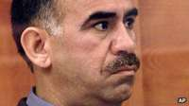

Image copyright AP

Kurdistan Workers' Party leader Abdullah Ocalan is serving a life sentence

[**Kurdish leaders charged in Turkey**](http://www.bbc.com/news/world-europe-14393231)

**1998**January - Welfare Party - the largest in parliament - banned. Yilmaz resigns amid corruption allegations, replaced by Bulent Ecevit.

**1999**February - PKK leader Abdullah Ocalan captured in Kenya.

**2001**June - Constitutional Court bans opposition pro-Islamic Virtue Party, saying it had become focus of anti-secular activities.

**2002**January - Turkish men are no longer regarded in law as head of the family. The move gives women full legal equality with men, 66 years after women's rights were put on the statute books.

**2002**August - Parliament approves reforms aimed at securing EU membership. Death sentence to be abolished except in times of war and bans on Kurdish education, broadcasting to be lifted.

**Islamist party victorious**

**2002**November - Islamist-based Justice and Development Party (AK) wins landslide election victory. Party promises to stick to secular principles of constitution. Deputy leader Abdullah Gul appointed premier.

**2002**December - Constitutional changes allow head of ruling AK Party, Recep Tayyip Erdogan, to run for parliament, and so to become prime minister. He had been barred from public office because of previous criminal conviction.

**Kurdish rebels**

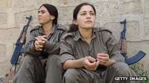

Image copyright GETTY IMAGES

The PKK - Kurdistan Workers Party - is a rebel group fighting for an independent Kurdish state within Turkey

* Founded in 1974. Took up arms against Turkey in 1984
* More than 40,000 people have been killed in conflict
* Listed as a terrorist organization by Ankara, US and EU
* Since his capture, founder Abdullah Ocalan has encouraged quest for Kurdish rights via political rather than military means
* Government has lifted some restrictions on Kurdish cultural and political rights to try to end conflict
* Kurds say restrictions and mass arrests of Kurdish politicians have continued

**2003**March - AK Party leader Recep Tayyip Erdogan wins seat in parliament. Within days Abdullah Gul resigns as prime minister and Erdogan takes over.

Parliament decides not to allow deployment of US forces ahead of war in Iraq but allows US use of Turkish air space. It authorizes dispatch of Turkish forces into Kurdish areas of northern Iraq.

**2003**June-July - Eyeing future EU membership, parliament passes laws easing restrictions on freedom of speech, Kurdish language rights, and on reducing political role of military.

**Istanbul attacks**

**2003**November - 25 people are killed and more than 200 injured when two car bombs explode near Istanbul's main synagogue. Days later two coordinated suicide bombings at the British consulate and a British bank in the city kill 28 people.

**2004**January - Turkey signs protocol banning death penalty in all circumstances, a move welcomed in EU circles.

**2004**May - PKK says it plans to end a ceasefire because of what it calls annihilation operations against its forces.

**2004**June - State TV broadcasts first Kurdish-language program.

**2004**September - Parliament approves penal reforms introducing tougher measures to prevent torture and violence against women. Controversial proposal on criminalizing adultery dropped.

**EU talks**

**2004**December - EU leaders agree to open talks in 2005 on Turkey's EU accession. The decision, made at a summit in Brussels, follows a deal over an EU demand that Turkey recognize Cyprus as an EU member.

**2005**January - New lira currency introduced as six zeroes are stripped from old lira, ending an era in which banknotes were denominated in millions.

**2005**May - Parliament approves amendments to new penal code after complaints that the previous version restricted media freedom. The EU welcomes the move but says the code still fails to meet all its concerns on human rights.

**2005**June - Parliament overturns veto by secularist President Sezer on government-backed amendment easing restrictions on teaching of Koran.

**2005**October - EU membership negotiations officially launched after intense bargaining.

**2005**November - Multi-billion-dollar Blue Stream pipeline carrying Russian gas under the Black Sea to Turkey opens in the port of Samsun.

**Hrant Dink**

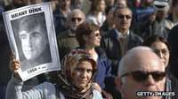

Image copyright GETTY IMAGES

Murder of journalist Hrant Dink shocked Turkey

[**Turkish-Armenian writer shunned silence**](http://news.bbc.co.uk/1/hi/world/europe/6280687.stm)

**2006**May - Gunman opens fire in Turkey's highest court, killing a prominent judge and wounding four others. Thousands protest against what they perceive as an Islamic fundamentalist attack.

**2006**June - Parliament passes new anti-terror law which worries the EU and which rights groups criticize as an invitation to torture.

**2006**July - Baku-Tbilisi-Ceyhan oil pipeline opened at ceremony in Turkey.

**2006**30 September - Kurdish separatist group, the PKK, declares a unilateral ceasefire in operations against the military.

**2006**December - EU partially freezes Turkey's membership talks because of Ankara's failure to open its ports and airports to Cypriot traffic.

**2007**January - Journalist and Armenian community leader Hrant Dink is assassinated. The murder provokes outrage in Turkey and Armenia. Prime Minister Erdogan says a bullet has been fired at democracy and freedom of expression.

**Secularist protests**

**2007**April - Tens of thousands of supporters of secularism rally in Ankara, aiming to pressure Prime Minister Erdogan not to run in presidential elections because of his Islamist background.

Ruling AK Party puts forward Foreign Minister Abdullah Gul as its candidate after Mr. Erdogan decides not to stand. He narrowly fails to win in the first round.

**2007**May - Parliament gives initial approval to a constitutional change allowing the president to be elected by a popular vote, but the amendment is vetoed by President Sezer.

**Headscarf row**

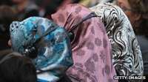

Image copyright GETTY IMAGES

The headscarf issue divides religious and secularist Turks

[**Headscarf issue challenges Turkey**](http://news.bbc.co.uk/1/hi/world/europe/6122010.stm)

[**Why Muslim women wear the veil**](http://news.bbc.co.uk/1/hi/world/middle_east/5411320.stm)

[**Quiet end to Turkey's college headscarf ban**](http://www.bbc.com/news/world-europe-11880622)

**2007**July - AK Party wins parliamentary elections. Abdullah Gul elected president the following month.

**2007**October - Voters in a referendum back plans to have future presidents elected by the people instead of by parliament.

**2007**December - Turkey launches a series of air strikes on fighters from the Kurdish PKK movement inside Iraq.

**Headscarf dispute**

**2008**February - Thousands protest at plans to allow women to wear the Islamic headscarf to university.

**2008**July - Petition to the constitutional court to have the governing AK Party banned for allegedly undermining the secular constitution fails by a narrow margin.

**2008**October - Trial starts of 86 suspected members of shadowy ultra-nationalist Ergenekon group, which is accused of plotting a series of attacks and provoking a military coup against the government.

**2009**July - President Abdullah Gul approves legislation proposed by the ruling AK Party giving civilian courts the power to try military personnel for threatening national security or involvement in organized crime.

**Rapprochement with Armenia**

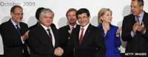

Image copyright GETTY IMAGES

Turkey and Armenia began edging towards a restoration of ties in 2009

[**Turkey, Armenia split on new ties**](http://news.bbc.co.uk/1/hi/world/europe/8306641.stm)

**2009**October - The governments of Turkey and Armenia agree to normalize relations at a meeting in Switzerland. Both parliaments will need to ratify the accord. Turkey says opening the border will depend on progress on resolving the Nagorno-Karabakh dispute between Armenia and Azerbaijan.

**2009**December - The government introduces measures in parliament to increase Kurdish language rights and reduce the military presence in the mainly-Kurdish southeast as part of its "Kurdish initiative".

**Constitutional reform**

**2010**April - Parliament begins debating constitutional changes proposed by the government with the stated aim of making Turkey more democratic. The opposition Republican People's Party says the Islamist-leaning ruling AK Party is seeking more control over the secular judiciary.

**2010**May - Relations with Israel come under severe strain after nine Turkish activists are killed in an Israeli commando raid on an aid flotilla attempting to reach Gaza.

**2010**September - Referendum on constitutional reform backs amendments to increase parliamentary control over the army and judiciary.

**Coup 'plots'**

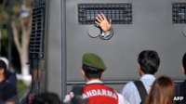

Image copyright AFP

Hundreds of army officers have been tried in connection with alleged coup plots, in what is seen as a blow to the military's power

**2010**November - The whistle-blowing website Wikileaks publishes confidential cables revealing that France and Austria have been deliberately blocking Turkey's EU membership negotiations.

**2011**June - Ruling Justice and Development (AK) Party wins resounding victory in general election. PM Erdogan embarks on third term in office.

Thousands of refugees fleeing unrest in Syria stream into Turkey. Ankara demands reform in Syria.

**2011**August - President Gul appoints top military leaders after their predecessors resign en masse. This is the first time a civilian government has decided who commands the powerful armed forces.

**2011**October - PKK rebels kill 24 Turkish troops near the Iraqi border, the deadliest attack against the military since the 1990s.

**2012**June - Turkey permits schools to offer the Kurdish language as an optional course.

**2012**October - Tension rises with Damascus. After Syrian mortar fire on a Turkish border town kills five civilians, parliament authorizes military action inside Syria, and the armed forces respond with artillery fire into Syria.

**2013** March - Following protracted talks between Turkish government and jailed PKK leader, Mr. Ocalan announces end of armed struggle and ceasefire.

**Summer of protest**

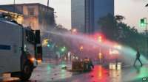

Image copyright AP

Anger at plans to redevelop an Istanbul park spilled over into protests against perceived government authoritarianism in mid-2013

**Protests**

**2013**May-June - Mass anti-government protests spread to several cities, sparked by plans to develop one of Istanbul's few green spaces. The police respond with violence, and two protestors die. Prime Minister Erdogan responds with defiance.

**2013** December - Government sacks numerous police chiefs over arrests of pro-government public figures on corruption charges. Observers see this as part of power struggle with former AK Party ally and influential US-based Muslim cleric Fethullah Gulen.

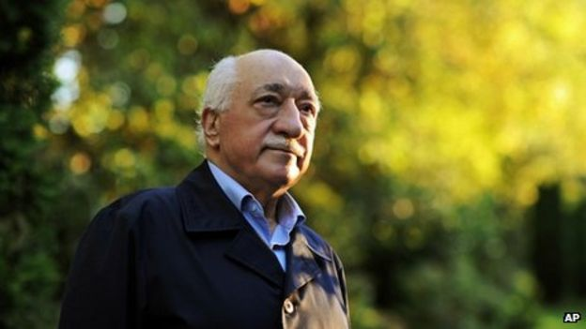

Image copyright AP Image caption Islamic preacher Fethullah Gulen - ally turned arch-rival to President Erdogan

**Erdogan presidency**

**2014**August - Prime Minister Erdogan wins the first direct popular election for president.

**2015** March - The "Sledgehammer" coup plot trial collapses when a court clears 236 military officers accused of involvement in an alleged conspiracy to remove former Prime Minister Erdogan from power in 2003.

**2015**June - The pro-Kurdish leftwing People's Democratic Party (HDP) enters parliament at elections, depriving the governing AK party of its majority and scuppering plans for a referendum on executive powers for President Erdogan.

**2015**July - Turkey announces air strikes against Islamic State militant group after suspected IS suicide bomber kills 32 young activists at rally in Suruc, on the Syrian border.

Ceasefire with the Kurdish rebel PKK - declared by jailed PKK leader Abdullah Ocalan in 2013 - finally crumbles under the weight of tensions aggravated by the Syrian civil war and the role of both Turkey and the Kurds in the war. Kurdish insurgency erupts once more.

**2015**October - Turkey accuses Islamic State of twin suicide bomb attacks on Ankara peace rally by Kurds that kills 100 people.

**Spillover of Syria conflict**

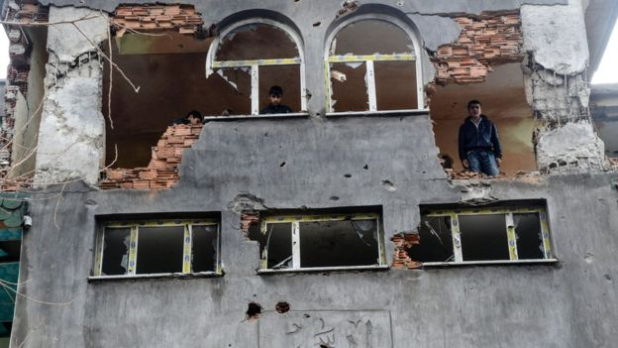

Image copyright AFP Image caption The breakdown of the ceasefire between the government and Kurdish rebels prompted renewed fighting in the south-east

**2015**November - Governing AKP party regains parliamentary majority in snap elections, but falls short of numbers needed for referendum to boost President Erdogan's powers.

Turkey shoots down a Russian military jet on Syria bombing mission. Russia, Turkey's second-largest trading partner, imposes economic sanctions.

European Union strikes a deal whereby Turkey restricts flow of migrants into Europe, in return for €3bn ($3.17bn) and concessions on stalled EU accession talks.

**2016** February - Bomb attack on military convoy in the capital Ankara kills at least 38 people. A hard-line breakaway PKK faction - the Kurdistan Freedom Hawks (TAK) - claims responsibility.

**Media crackdown**

**2016** March - Authorities put Turkey's biggest newspaper, Zaman - closely linked to Erdogan rival Fethullah Gulen - under state control.

Suicide car-bomb attack in Ankara kills 37 people. TAK again claims responsibility.

**2016** May - Prime Minister Ahmet Davutoglu resigns as prime minister after falling out with President Erdogan.

President Erdogan says that deal on restriction of flow of migrants into Europe - largely negotiated by Mr. Davutoglu - could collapse if Turks are not granted visa-free access to the EU.

**2016** June - Turkey recalls its ambassador to Berlin after German parliament adopts resolution declaring as genocide the killing of Armenians by Ottoman Turkish forces during WW1.

A gun and suicide attack on Istanbul's Ataturk airport kills 42 people, including 13 foreign nationals. Turkish authorities believe the attack bears the hallmarks of so-called Islamic State.

**Coup attempt**

**2016**July - The authorities detain thousands of soldiers and judges on suspicion of involvement in a coup attempt that President Erdogan says was inspired by his exiled opponent Fethullah Gulen.

The government also shuts down dozens of media outlets - including 16 TV channels - during a continuing crackdown in the wake of the failed coup attempt.

**2016** August - President Erdogan visits St Petersburg for talks with Russian President Vladimir Putin. The two men pledge to restore the close economic ties that were badly affected after Turkey shot down a Russian bomber on the Syrian border in November 2015.

**2016**December - Off-duty policeman kills Russian ambassador in apparent revenge for Russian air campaign in Syria. Russia and Turkey pledge to cooperate with Iran in fight against Islamic State in Syria.

**2017**January - Gunman kills 39 people celebrating New Year at the Reina nightclub in Istanbul. The so-called Islamic State group says it was behind the attack.